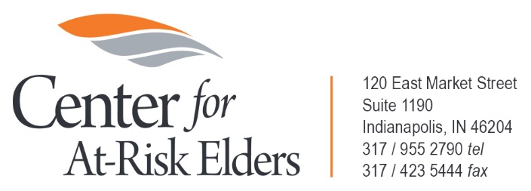

Significant Asset Cases Referral Program

Application

This application is available in Word format at www.indianacare.org/SACApplication.
Please email your application to Michelle Niemier at michelle@indianacare.org.

NAME (Individual or Organization):______________________________________

D/B/A (if applicable):_________________________________________________

ADDRESS: _______________________________________________________

PHONE: _______________________________________________________

EMAIL: _______________________________________________________

Individual Applicants

1. Number of years’ experience as a guardian: __________

2. Number of current guardianship clients:__________

3. I am a National Certified Guardian (NCG) in good standing.

_____Yes ______No

4. I am willing and able to serve as both the “guardian of the person” and “guardian of the estate” in cases where both roles are found by the court to be necessary.

_____Yes ______No

5. Please describe your defined succession plan in the event you are no longer able to serve as guardian (retirement, relocation, death or disability).
__________________________________________________________________________
__________________________________________________________________________
__________________________________________________________________________
__________________________________________________________________________

6. I agree to designate a “Stand-By Guardian” for any case referred to me by CARE.

_____Yes ______No

7. I commit to a “no-abandonment” principle, meaning that I will not seek to resign as guardian (unless another suitable successor guardian is identified) just because the client’s funds capable of paying the guardian’s fees have been exhausted.

_____Yes ______No

8. Have you ever been removed as guardian in a guardianship case for malfeasance, or had a surcharge asserted against any surety bond I might have posted in prior guardianships?

_____Yes ______No

Organization Applicants

1. Number of years our organization has provided guardian services: _________

2. Number of current guardianship clients:__________

3. Our organization has at least one principal owner that is a National Certified Guardian (NCG.)

_____Yes ______No

4. Our organization agrees to abide by the National Guardianship Association’s “Standards of Practice for Agencies and Programs Providing Guardianship Services” unless a request for waiver of any parts thereof is approved by the CARE Board of Directors.

_____Yes ______No

5. Our organization is willing and able to serve as both the “guardian of the person” and “guardian of the estate” in cases where both roles are found by the court to be necessary.

_____Yes ______No

6. Our organization commits to a “no-abandonment” principle, meaning that it will not seek to resign as guardian (unless another suitable successor guardian is identified) just because the client’s funds capable of paying the guardian’s fees have been exhausted.

_____Yes ______No

7. Has your organization, or any of its principals, ever been removed as guardian in a guardianship case for malfeasance, or had a surcharge asserted against any surety bond that might have posted in prior guardianships?

_____Yes ______No

I hereby swear or affirm that the foregoing statements are true. If the Applicant is an organization, then the person signing below swears or affirms that they are a duly authorized agent of the organization.

Dated:________________ _______________________________________
Signature of Applicant

_______________________________________
Printed Name

_______________________________________
Title (if Applicant is Organization)

____________________________________________________________________________
FOR INTERNAL CARE USE ONLY

The Applicant above is hereby found to be a Qualified Professional Guardian as defined by the Board of Directors of the Center for At-Risk Elders, Inc. and is entered in to the rotation of referrals as of the date written below.

___________________ _______________________________________
Date Deputy Director, Center for At-Risk Elders, Inc.
6/2022

